Spaghetti Noodle Bridge Lab
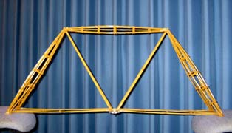

Today you will conduct a lab investigating the weight capacity of spaghetti noodles when building a spaghetti noodle bridge.
Materials needed to conduct his lab include:
Spaghetti noodles (thick, thin, and regular)
Plastic cups
Whole punch
Pipe cleaners
Pennies
Scissors
2 stacks of books ( 16 textbooks in all)

With the following materials students should be able to develop a testable question.

Testable Question: ____________________________________________________________________________________________________________________

What is the independent variable? ________________________________________________________________

What is the dependent variable? ________________________________________________________________
What is the control group? _________________________________________________________________

What are the constants for this experiment? ____________________________________________________________________________________________________________________
Hypothesis____________________________________________________________________________________________________________
Procedure:
Step 1: Using the hole punch make two holes on opposite sides of the plastic cup.
Step 2: cut he pipe cleaner to about 6 inches.
Step 3: Place the pipe cleaner into the hole of the cup forming a handle, twist the pipe cleaner tightly to secure the handle .
Step 4: Make two stacks of 8 books in a pile.
Step 5: Place the two stacks of books directly opposite of each other making a gap between them.
Step 6: Place a penny into the bucket.
Step 7: Gently thread the thin noodle through the bucket.
Step 8: Gently place the spaghetti noodle and bucket across the two stacks of books .
Step 9: If the noodle does not break place one penny at a time into the bucket until the noodle breaks.
Step 10: Count the number of pennies in the bucket and record your data.
Step 11: Repeat this process two more times with the thin noodles.
Step 12: Repeat steps 7 through 11 with the regular and thick noodles.
Data:
Title :__________________________________________________________

Thickness of Spaghetti Noodle | Number of Pennies Held  T1 T2 T3 |  |  | AVG

Graph:

Title:______________________________________________________

Conclusion:

