Name of Rock | Picture and Description | Where it forms | Composition | Texture
Granite | 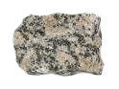
Rhyolite | 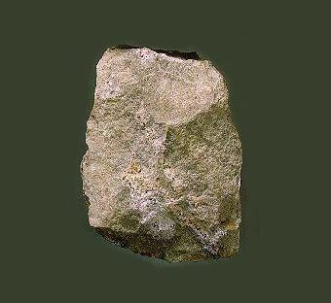
Pumice | 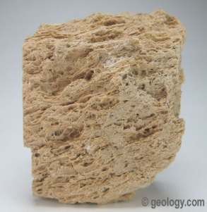
Obsidian | 